**UIPath Daily Sanity Oracle Installation**

**UIPath is a 32-bit program so only 32-bit oracle is compatible**

Required Software:

* - Oracle Instant Client 12_2 (32-bit)
  + Basic
  + ODBC
  + sdk
* Oracle 11g Release 2 (32-bit)
* Microsoft C++ Redistributable 2015-2019

UIPath Connection String example:

"Server=(DESCRIPTION=(ADDRESS_LIST=(ADDRESS=(PROTOCOL=TCP)(HOST=<DB_address>)(PORT=<Port_num>)))(CONNECT_DATA=(SERVICE_NAME=<DB_Name>)));Uid=<username>;Pwd=<password>"

Steps to Install Oracle Instant Client 12_2 (32-bit)

1. Download the Oracle Instant Client 12_2 (32-bit) files from Oracle website
   1. Basic
   2. ODBC
   3. SDK
2. create "oracle" folder in C:\
3. Extract all 3 zip files to the same folder inside the created oracle folder (C:\oracle\InstantClient_12_2)
4. Run "odbc_install.exe" as administrator
5. Add instant client location to PATH environment  
   (Windows)
   1. In Start Search "Environment Variables"
   2. Click "Edit System Environment Variables"
   3. Click "Environment Variables"
   4. Under System Variables double click on "Path"
   5. Click "New"
   6. paste file path of instant client install location (Example: C:\oracle\instantclient_12_2)
   7. Move path up until it right below Oracle 11g path (or top)

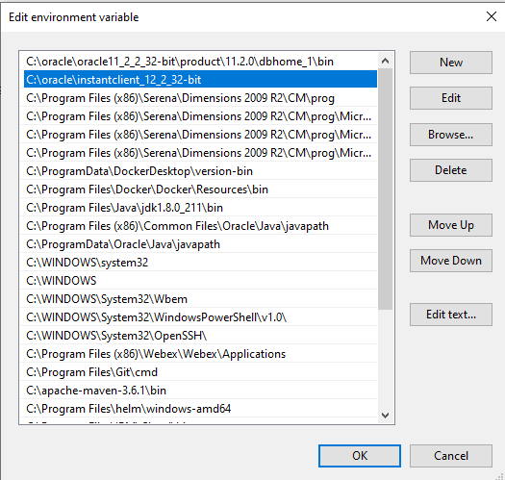

1. Restart PC

**------------------------------------------------------------------------------------------------------------------------------------------**

**Continue only if you are still getting an error connecting to DB after restarting**

**If UIPath still gives Error finding client or connecting to DB, continue to next step**

Steps to Install Oracle DB 11g Release 2 32-bit

1. create "oracle" folder in C:\ if you have not sone so
2. Download and extract Oracle 11g Release 2 32-bit from Oracle site (Parts 1 and 2)
3. run "setup.exe"
4. Ignore "Environment does not meet minimum requirements" error  
   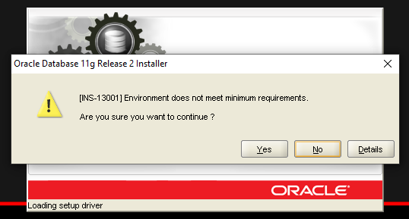
5. Uncheck “I wish to receive security updates via My Oracle Support”  
   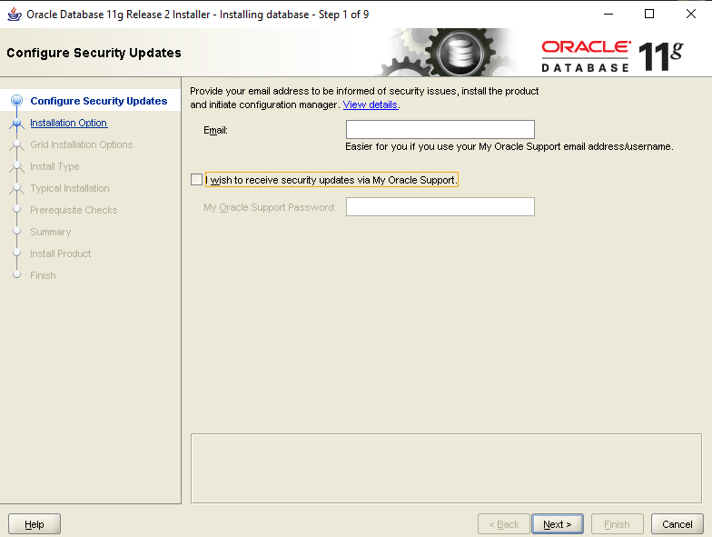
6. Select “Yes” for “Do you wish to remain uninformed of critical security issues in your configuration?”   
   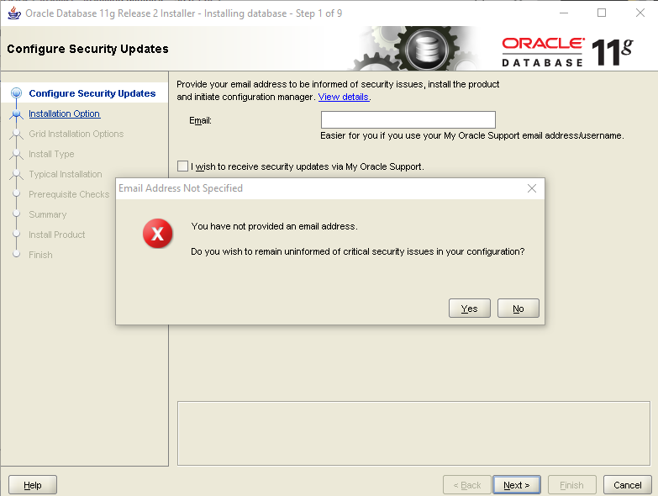
7. Install Database Software Only  
   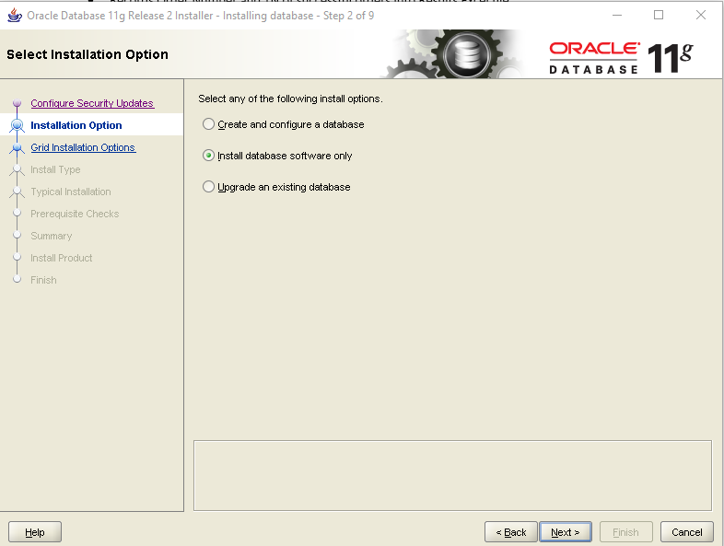
8. Single Instance Database installation  
   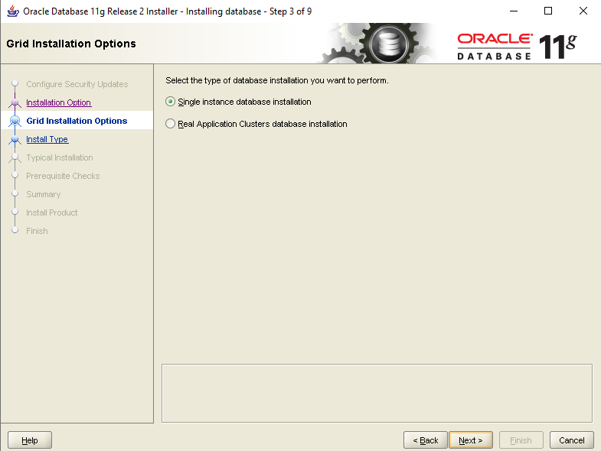
9. Select desired language  
   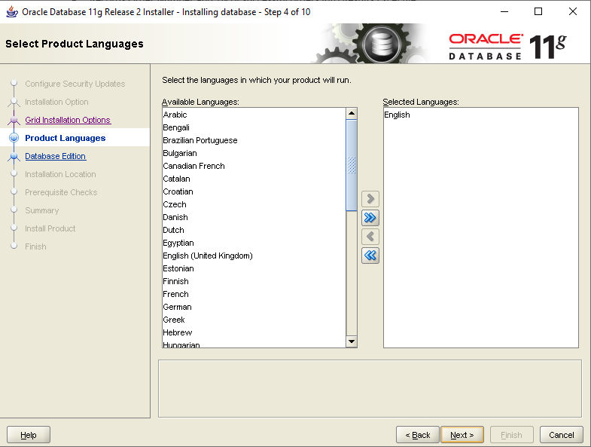
10. Enterprise Edition  
    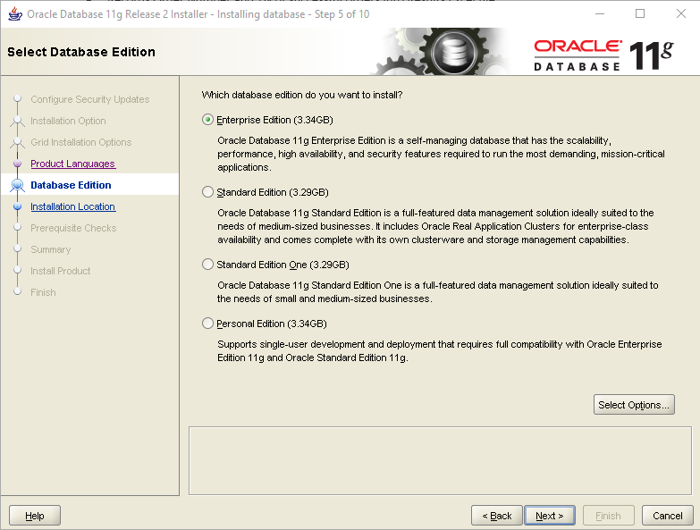
11. Change Oracle Base Location to your “C:\oracle” folder
    1. DO NOT CHANGE SOFTWARE LOCATION unless you have a pre-existing installation
    2. If Pre-existing install, change dbhome_1 name to something like dbhome_2

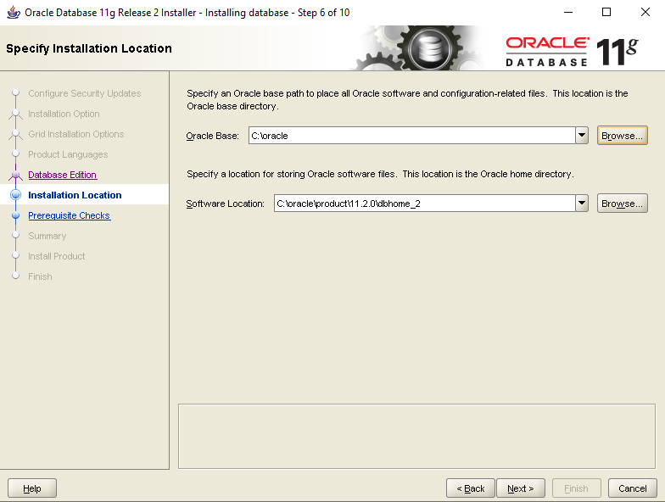

1. Click Finish and wait for install to complete
2. Restart pc after completion

**If UIPath still gives Error finding client or connecting to DB, continue to Install Microsoft C++ Redistributable 2015-2019**